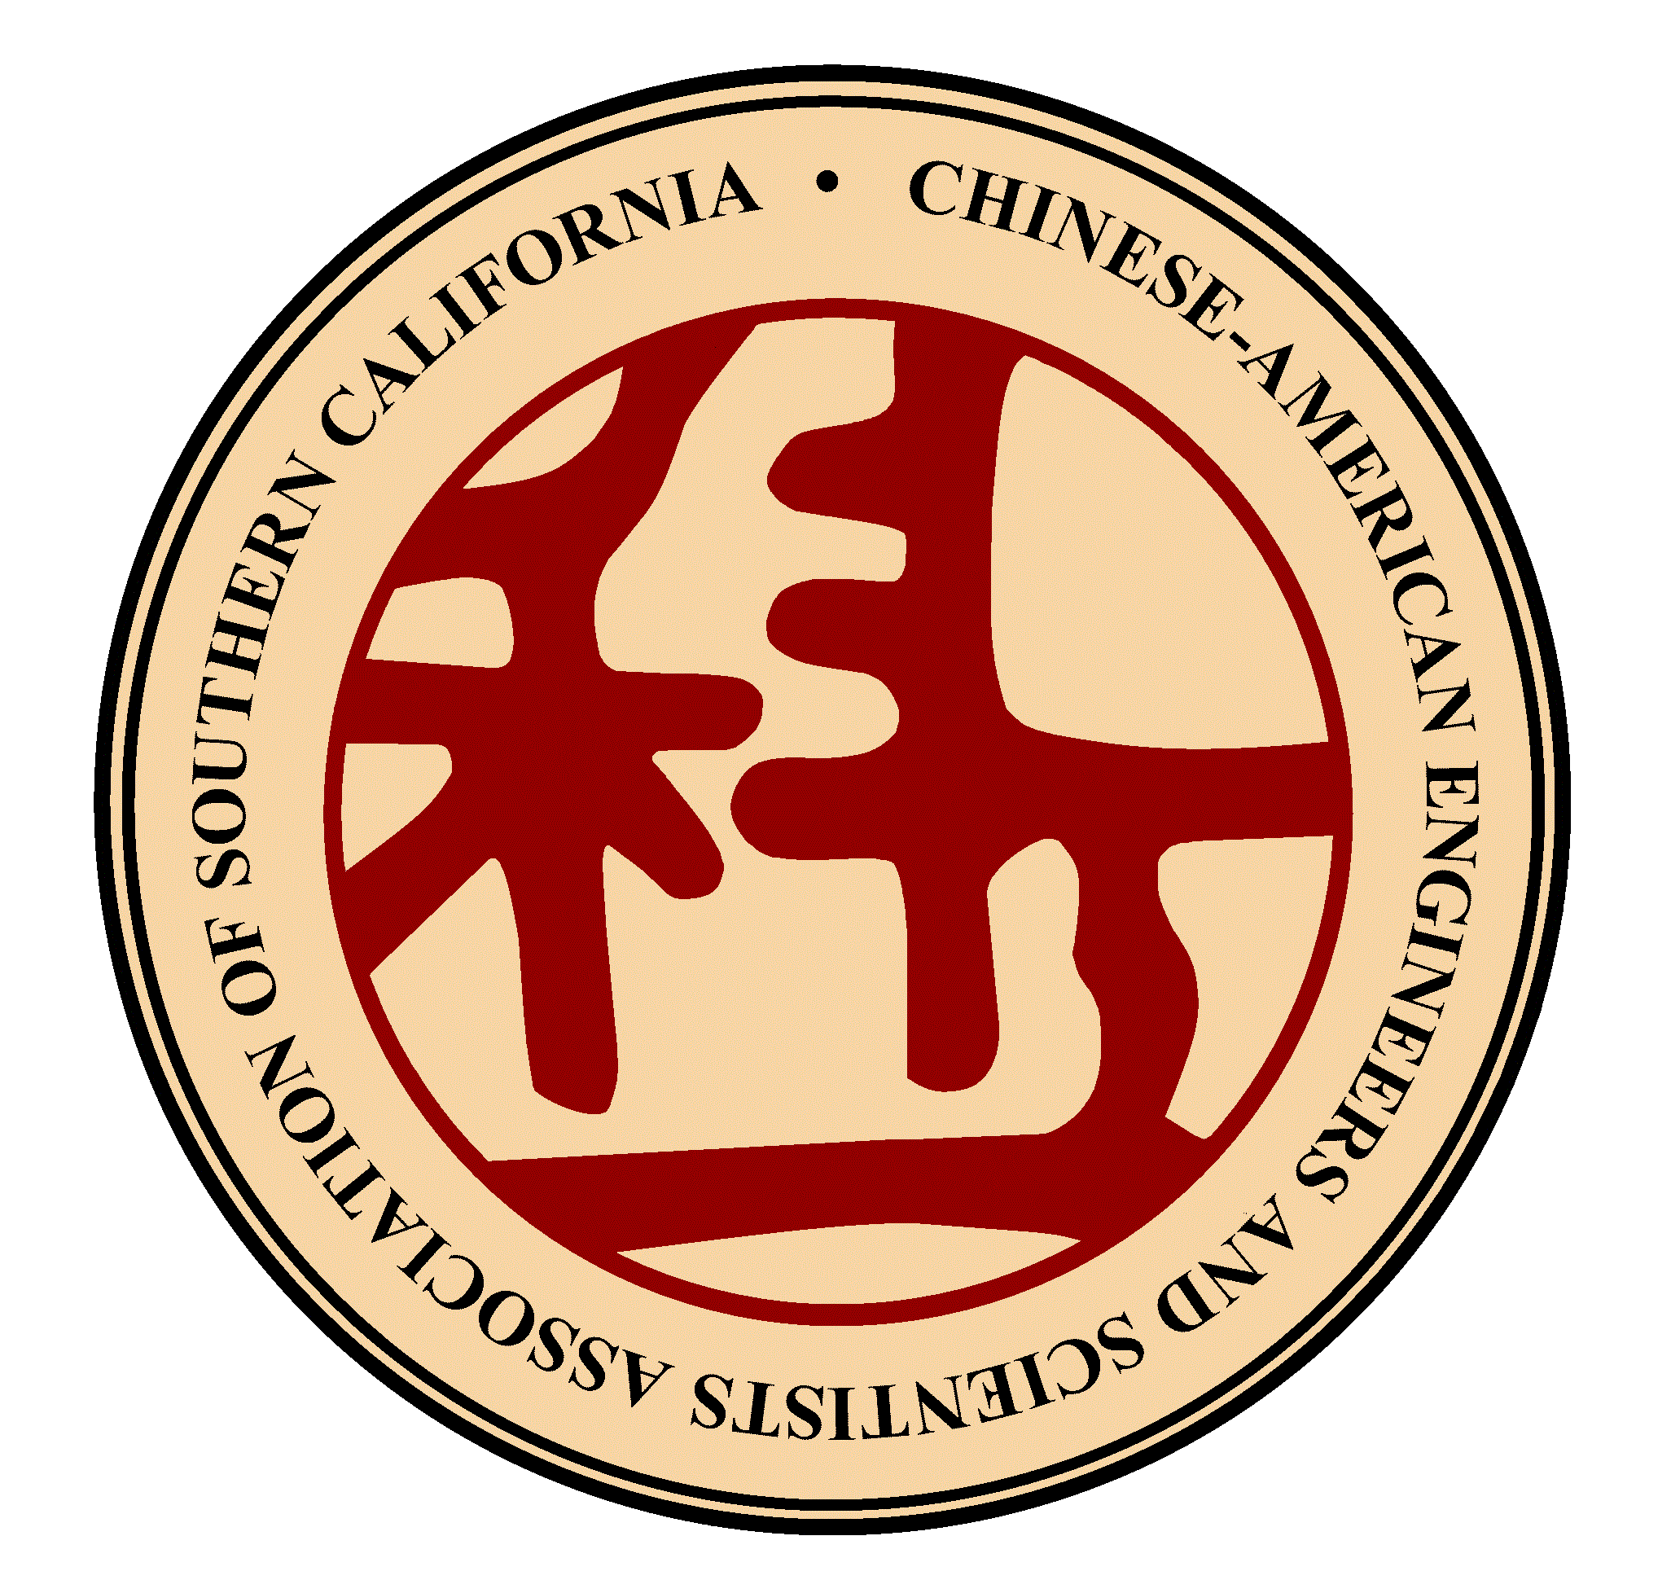
Chinese-American Engineers and Scientists Association of Southern California
Since 1962

Dear Engineers, Scientists, and college students,
On behalf of the Chinese-American Engineers and Scientists Association of Southern California (CESASC), we would like to invite you to participate in the 2017 Business Innovation Competition that promotes innovation, entrepreneurship and leadership for our Chinese-American engineers and scientists.
Founded in 1962, CESASC is one of the most established Chinese-American professional organizations in Southern California. One of our mission is to promote interests, aspirations, and professional excellence of Chinese-American engineers and scientists. Our guests and awardees in the past years include Nobel Laureates, industry leaders, university executives, and top public officials, such as Dr. Steve Chu(朱棣文), Dr. Chen Ning Yang (楊振寧), Dr. Chen-Dau Lee (李政道), Yuan T. Lee (李遠哲), Dr. Samuel C. C. Ting (丁肇中), Dr. David Ho (何大一), Dr. Shu Chien (錢煦), and Ms. Elaine L. Chao (趙小蘭), just to name a few. You can learn more about CESASC at http://www.cesasc.org.
The 2017 Business Innovation Competition is open to all the engineers, scientists, and college students. Based on submitted abstracts and business plans, 6-8 finalists will be chosen to present their business plans to a panel of judges on April 15, 2017 during the 55th CESASC annual convention day program. Winners will be announced at the CESASC annual convention evening gala, and also be invited to meet with business investors and innovation experts to discuss about further investments and co-operations. The top winning team will also be invited to a business venture camp in China in summer 2017.
Please help us notify your fellow students and postdocs about this opportunity. We look forward to hearing from all of you.
Thank you for your interest and best of luck in your entrepreneurial adventures.
Sincerely,

Xiwu Cao, Ph.D.
Chair, 2017 CESASC Business Innovation Committee

